PHENIKAA UNIVERSITY
PHENIKAA SCHOOL OF COMPUTING



WEEKLY REPORT
TOPIC: ELECTRONICS E-COMMERCE WEBSITE

Course Class : | Software Architecture-1-2-25 (N01)
Instructor : | M.Sc. Vũ Quang Dũng
Group : | 16
Group Members : | Nguyễn Tuấn Thiền - 23010571  Đặng Việt Anh – 23010689
Mục lục
Lab 01
1. Abstract/Summary 2
2. Lab Specific Section: Requirements Elicitation & Modeling 2
2.1 Software Requirements Specifications (SRS) 2
2.1.1 Actors Identification 2
2.1.2 Functional Requirements (FRs) 3
2.1.3 Non-Functional Requirements (NFRs) 3
2.2 Modeling Artifact: UML Use Case Diagram 8
2.2.1 System Context Diagram 8
2.2.2 Main Use Case Diagram 9
2.2.3 Critical Path: Make Purchase (Checkout Process) 11
3. Architectural Design (Problem Analysis for Lab 2) 12
3.1 The Problem Statement 12
3.2 Impact of ASRs on Layered Architecture 12
4. Conclusion & Reflection 13
5. References 13

1. Abstract/Summary
The Electronics E-Commerce Website project aims to develop a robust online retail platform for electronic products. This initial lab focused on requirements elicitation and modeling. We documented essential Functional, Non-Functional, and Architecturally Significant Requirements (ASRs) in a structured format. The core system behavior was formally modeled using a UML Use Case Diagram, clearly defining system boundaries, external actors, and key behavioral relationships.
This foundation establishes the scope and the critical architectural drivers that will be addressed in subsequent labs, particularly the design of the Layered Architecture in Lab 2.

2. Lab Specific Section: Requirements Elicitation & Modeling
This section documents the deliverables for Lab 1, as specified in the report requirements.

2.1 Software Requirements Specifications (SRS)
The following tables document the elicited requirements, which collectively form the basis for the Electronics E-Commerce Website design.

2.1.1 Actors Identification
Based on the Electronics E-Commerce scenario, the following primary actors interact with the system:
Actor | Description | Interaction
Web Customer | End users who browse and purchase electronic products online | Browse products, register/login, add to cart, make purchases, submit reviews
Administrator | Store managers who manage the e-commerce platform | Manage products, categories, orders, articles, user accounts, and view reports
Payment Gateway | External payment processing system (VNPay, MoMo) | Process payment transactions, verify payment information, return transaction status

2.1.2 Functional Requirements (FRs)
These requirements define the specific behaviors and functions the Electronics E-Commerce system must provide.
ID | Description | Priority
FR-01 | The system must allow a Web Customer to browse and search for electronic products using keywords and categories. | High
FR-02 | The system must allow a Web Customer to register an account and securely log in to the system. | High
FR-03 | The system must allow a Web Customer to add products to a shopping cart and manage quantities. | High
FR-04 | The system must support the Checkout process, including shipping information and payment processing (Make Purchase). | Critical
FR-05 | The system must allow a Web Customer to submit product reviews and ratings. | Medium
FR-06 | The system must allow an Admin to perform CRUD operations on product categories. | High
FR-07 | The system must allow an Admin to manage product inventory (add, edit, delete products). | High
FR-08 | The system must allow an Admin to view and update order statuses (Pending, Shipped, Completed). | High
FR-09 | The system must generate an order confirmation and send it to the customer upon successful purchase. | Medium
FR-10 | The system must allow an Admin to manage news articles/blog posts about electronics. | Low

2.1.3 Non-Functional Requirements (NFRs)
These requirements specify criteria that can be used to judge the operation of the system, not specific functions.
ID | Attribute | Description | Impact
NFR-01 | Performance | The system must respond to 90% of product search queries within 2.0 seconds under normal load. | High
NFR-02 | Security | All customer data, especially payment information, must be transmitted and stored using encryption (HTTPS, AES-256). | Critical
NFR-03 | Availability | The system must maintain a minimum of 99.9% uptime during operational hours. | Critical
NFR-04 | Scalability | The system must support at least 5,000 concurrent users during peak sales events. | High
NFR-05 | Usability | The user interface must be responsive and optimized for both desktop and mobile devices. | Medium

2.1.4 Architecturally Significant Requirements (ASRs)
These are the non-functional requirements that have the most profound influence on the system's architecture, driving the selection of patterns. If not met, the system is deemed a failure.
ASR ID | Quality Attribute | Requirement Statement | Architectural Rationale
ASR-1 | Scalability | The architecture must support rapid horizontal scaling to accommodate 500 to 5,000 concurrent users during seasonal peak sales. | Drives consideration of component separation, load balancing, and horizontal deployment strategies.
ASR-2 | Security | All access to administration functionalities must be restricted to authenticated and authorized Admin users via secure token validation. | Necessitates a dedicated Security Component and Gateway Pattern for authentication checking.
ASR-3 | Modifiability | Integrating a new third-party Payment Gateway must not require changes to the Product Inventory or User Management components. | Enforces Separation of Concerns, driving layered or componentized structure with well-isolated business logic.

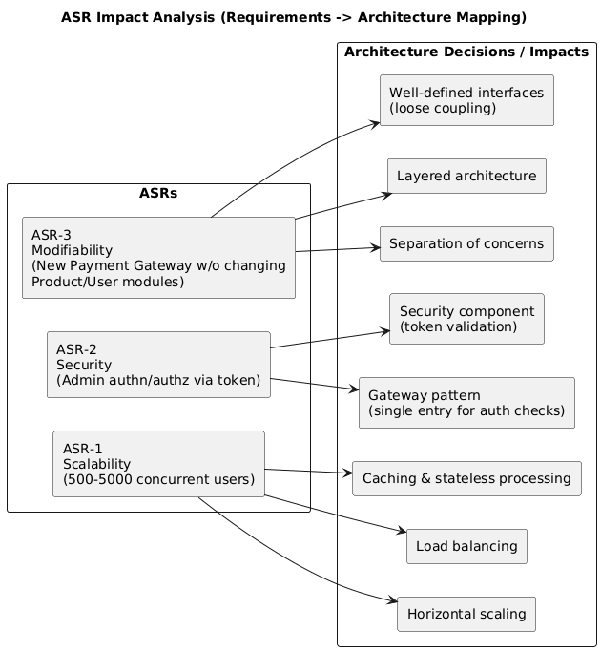
Figure 2.1: ASR Impact Analysis - Requirements to Architecture Mapping

Detailed ASR Cards:
ASR Card 1: High Scalability
- ASR: High Scalability (NFR)
- Statement: The system must handle a surge of 5,000 concurrent active users during peak sales events.
- Impact: Drives the choice towards distributed architectures, stateless processing, effective load balancing, and caching strategies.
ASR Card 2: Security & Access Control
- ASR: Security (NFR)
- Statement: Customer passwords and payment details must comply with industry standards. Admin access must be strictly controlled.
- Impact: Forces Gateway Pattern implementation with single point for authentication/authorization checking before routing requests.
ASR Card 3: Modifiability & Loose Coupling
- ASR: Modifiability (NFR)
- Statement: The system must allow integration of new payment methods without affecting other modules.
- Impact: Enforces strict Separation of Concerns with clear interfaces between layers. Layered Architecture is chosen.

2.1.5 Requirements-to-Code Traceability
To ensure the written requirements align with the delivered source code , the functional requirements are mapped to the main domain modules found in the repository (Modules/*). This traceability supports verification, testing, and future architecture work in Lab 2.
Note: Some requirements span multiple modules (e.g., checkout touches Cart and Payment). This mapping reflects the primary responsibility based on repository structure.
FR ID | Requirement (short) | Primary code module(s)
FR-01 | Browse product catalog (by category) | Modules/Catalog
FR-02 | Search products by keyword/filter | Modules/Catalog
FR-03 | View product details | Modules/Catalog
FR-04 | Manage shopping cart (add/update/remove) | Modules/Cart
FR-05 | User registration & login | Modules/Customer
FR-06 | Place order / checkout | Modules/Cart, Modules/Payment
FR-07 | Online payment processing | Modules/Payment
FR-08 | View order history & status | Modules/Customer, Modules/Support
FR-09 | Submit product reviews/ratings | Modules/Review
FR-10 | Admin management (products/orders/content) | Modules/Admin, Modules/Content

2.2 Modeling Artifact: UML Use Case Diagram
The UML Use Case Diagram models the functional scope of the Electronics E-Commerce system, showing the system boundary, the external Actors, and the core Use Cases.

2.2.1 System Context Diagram
The System Context Diagram shows the system boundary and how it interacts with external entities.
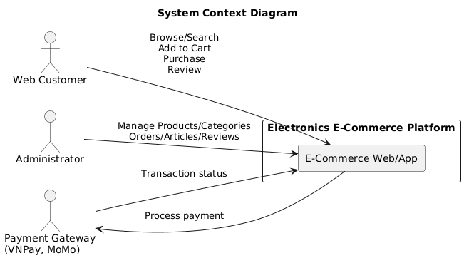
Figure 2.2: System Context Diagram - Electronics E-Commerce Platform

2.2.2 Main Use Case Diagram
The main Use Case Diagram shows all actors, use cases, and their relationships within the system boundary.
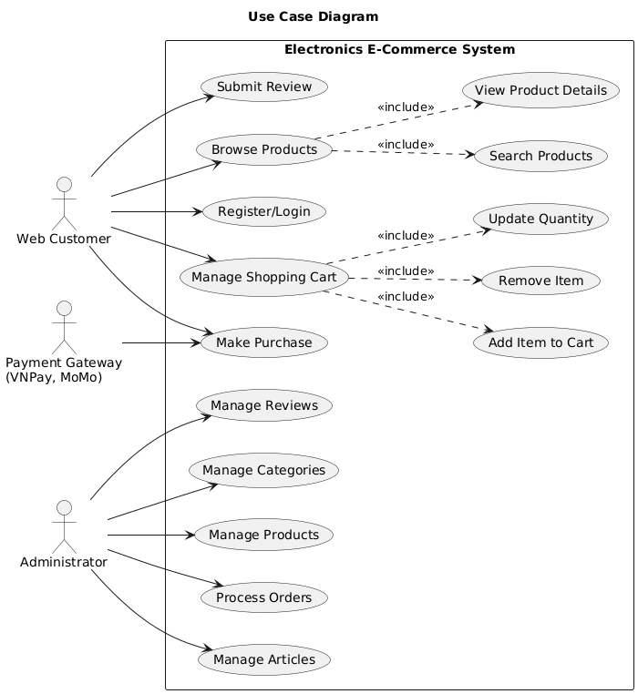
Figure 2.3: UML Use Case Diagram - Electronics E-Commerce System
Note: Figure 2.3 highlights both customer-facing and key administrative use cases for completeness; Figure 2.4 then expands the critical 'Make Purchase' checkout flow using «include»/«extend» relationships for clarity.
Actors (overall):
- Web Customer: End users who browse, search, and purchase electronic products.
- Administrator: Store managers who manage products, orders, and system content.
- Payment Gateway (External): Third-party payment processing service (VNPay, MoMo).
Customer Use Cases:
- Browse Products - Search and view electronic products by category
- Register/Login - Create account and authenticate
- Manage Shopping Cart - Add, remove, update product quantities
- Make Purchase - Complete the checkout process (Critical Path)
- Submit Review - Rate and review purchased products
Administrator Use Cases:
- Manage Categories - CRUD operations on product categories
- Manage Products - Add, edit, delete product inventory
- Process Orders - View and update order statuses
- Manage Articles - Create and publish news/blog posts
- Manage Reviews - View and moderate customer reviews

2.2.3 Critical Path: Make Purchase (Checkout Process)
The diagram below details the Checkout process, which is the critical path for the system. It shows the include and extend relationships as required by Lab 01.
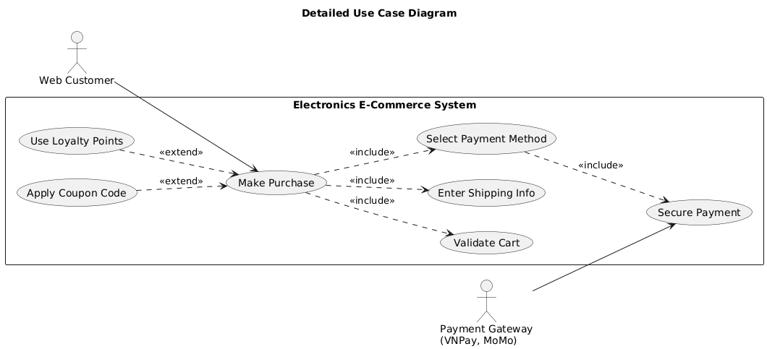
Figure 2.4: Detailed Use Case Diagram - Make Purchase (Checkout Process)
Use Case Relationships:
Relationship | Use Cases | Description
<<include>> | Make Purchase -> Validate Cart | Mandatory: Cart must be validated before checkout.
<<include>> | Make Purchase -> Enter Shipping Info | Mandatory: Shipping information is required.
<<include>> | Make Purchase -> Select Payment Method | Mandatory: Payment method must be selected.
<<include>> | Select Payment -> Secure Payment | Mandatory: Payment is processed through Payment Gateway.
<<extend>> | Apply Coupon Code -> Make Purchase | Optional: Customer may apply a discount coupon.
<<extend>> | Use Loyalty Points -> Make Purchase | Optional: Customer may use loyalty points for discount.

3. Architectural Design (Problem Analysis for Lab 2)
The requirements elicited in Lab 1 have a direct impact on the design challenge of Lab 2: Layered Architecture Design.

3.1 The Problem Statement
The problem is to design an architecture that satisfies the core requirements while enforcing separation of concerns and strict dependency rules. A Layered Architecture pattern is chosen as the first step to structure each feature into Controller, Service, and Repository responsibilities. In the provided source code, the system is also organised into domain modules (e.g., Catalog, Cart, Payment, Admin), and each module can apply the same internal layering to keep the codebase modular and maintainable.

3.2 Impact of ASRs on Layered Architecture
ASR-3 (Modifiability) -> Layered Structure:
ASR-3 demands that component changes remain isolated (e.g., a new Payment Gateway should not affect the Product component). The Layered Architecture inherently supports this by strictly defining four layers (Presentation, Business Logic, Persistence, Data) with downward dependencies. The Business Logic layer can be modified without impacting the Presentation layer, and the Persistence layer can be changed without affecting the Business Logic layer.
ASR-2 (Security) -> Business Logic Layer:
ASR-2 requires rigorous authorization for admin tasks. In the Layered Architecture, this logic is enforced in the Business Logic Layer. This ensures that security checks are applied to the core services (ProductService, OrderService), protecting them from unauthorized access regardless of whether the request originates from a web UI or an internal script.
The next step (Lab 2) will use these requirements to formally define the four architectural layers and model the logical components (Controller, Service, Repository) and their interfaces within those layers.

4. Conclusion & Reflection
The requirements elicitation phase for the Electronics E-Commerce Website successfully defined the project scope through detailed Functional, Non-Functional, and Architecturally Significant Requirements. The UML Use Case Diagrams provide clear visual models of user interactions and the critical checkout path.
Key takeaways from this lab:
- Architecture is Driven by NFRs: The 'how well' (NFRs) is often more important than the 'what' (FRs) when making architectural decisions.
- ASRs Dictate Patterns: Requirements like high scalability and security force choices away from simple solutions toward more sophisticated architectural patterns.
- UML Use Case View provides the initial contract between the system and the outside world, defining what the system does from an external perspective.
The identified ASRs—especially those relating to Modifiability, Security, and Scalability—directly necessitate the adoption of a structured pattern like the Layered Architecture for the subsequent design phase in Lab 2.

5. References
- Lab 1: Requirements Elicitation & Modeling - Course Materials
- Lecture 1: Software Architecture - Requirements Elicitation & Modeling
- Kruchten, P. - The 4+1 View Model of Architecture
- Ian Sommerville - Software Engineering, Ninth Edition, Addison-Wesley, 2011
- Project GitHub: https://github.com/ntt2308/webbanhang.git

